Internal UAT

* Unable to log in smoothly, need to refresh the page 3-5 time
* Polling frequency around 10 min or more which should be 1 minute interval
* Email sent with DN# on header, content and attachment of DN document but system took longer period to detect DN document
* Inconsistency of viewing OCR document (view below image), refreshed page but still fail to load PDF

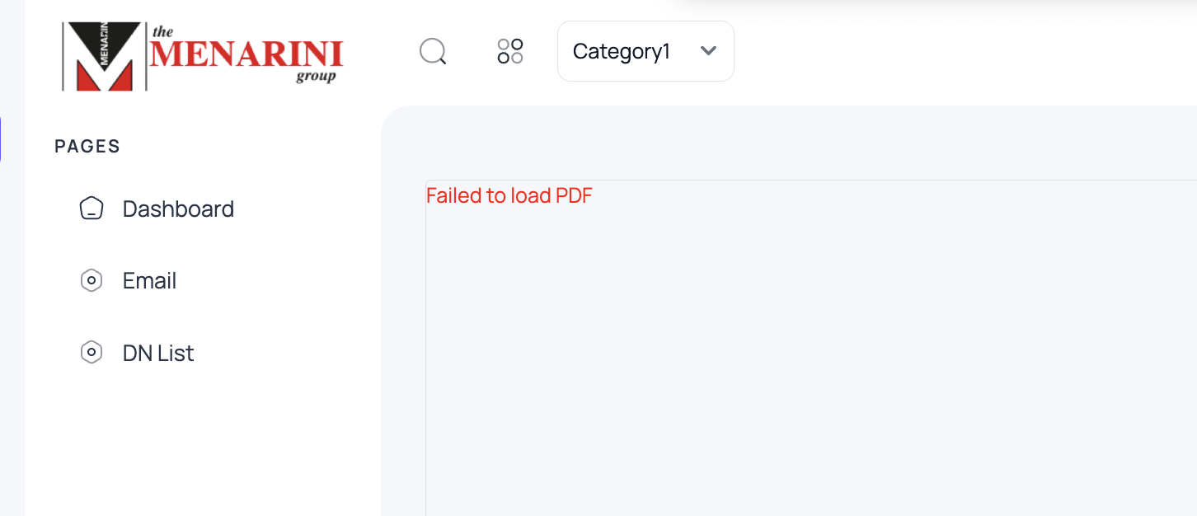

* Dashboard display data not up to date
* Webpage need to do manual refresh have to change to auto
* Spelling error “documnet” to “document”

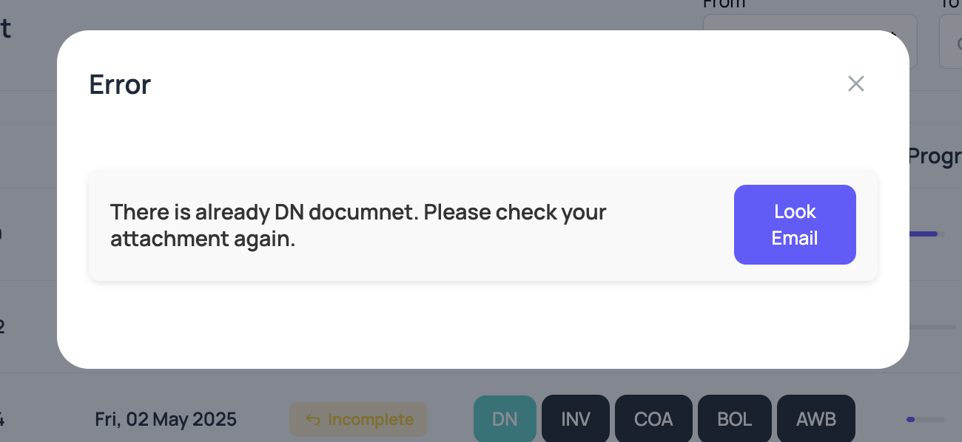

* OCR should capture Kyowa Kirin International (KKI) as vendor not Menarini Australia Pty Ltd

(View below image, and view 2nd image row number 4 supplier category) 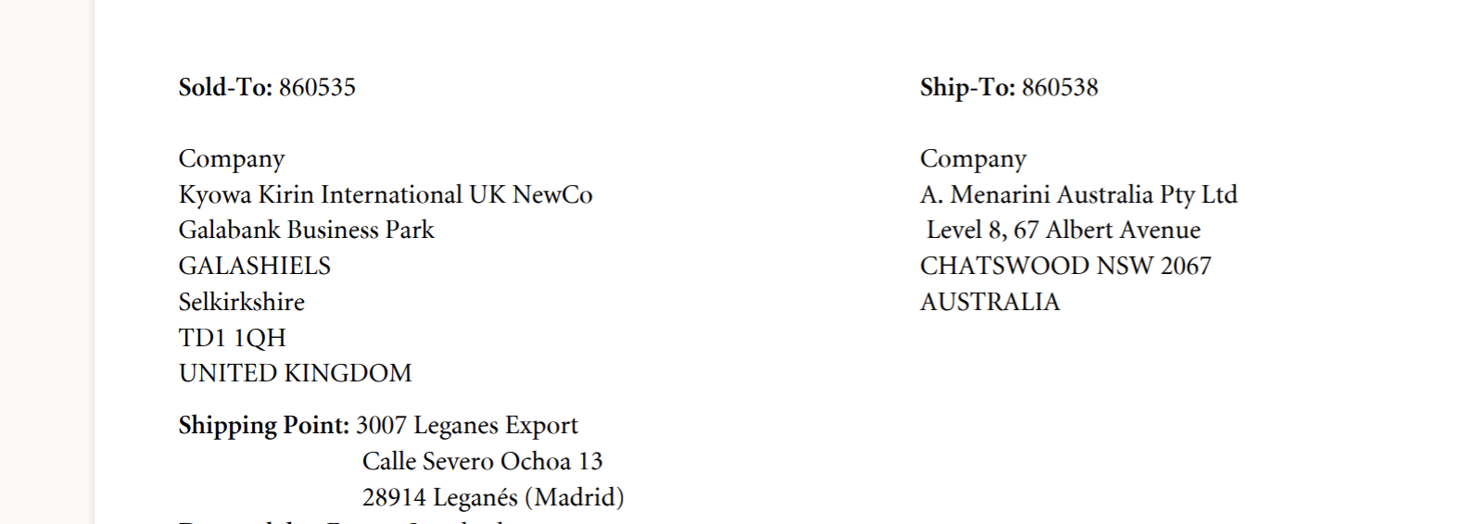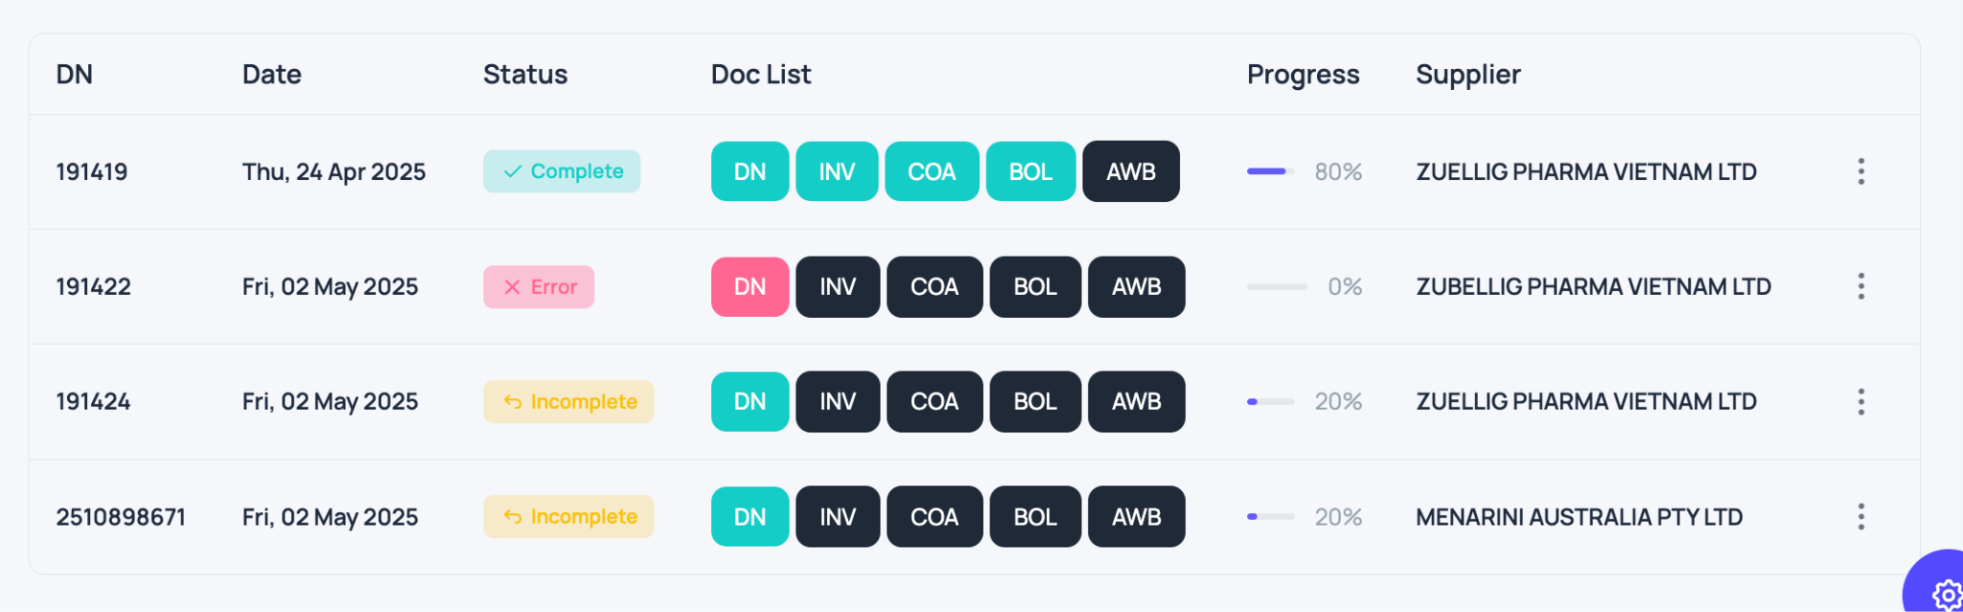

* OCR should capture Phardiag as vendor not ZUELLIG pharma vietnam  
  (View below image, and 2nd image row 1 - 3, supplier category)  
  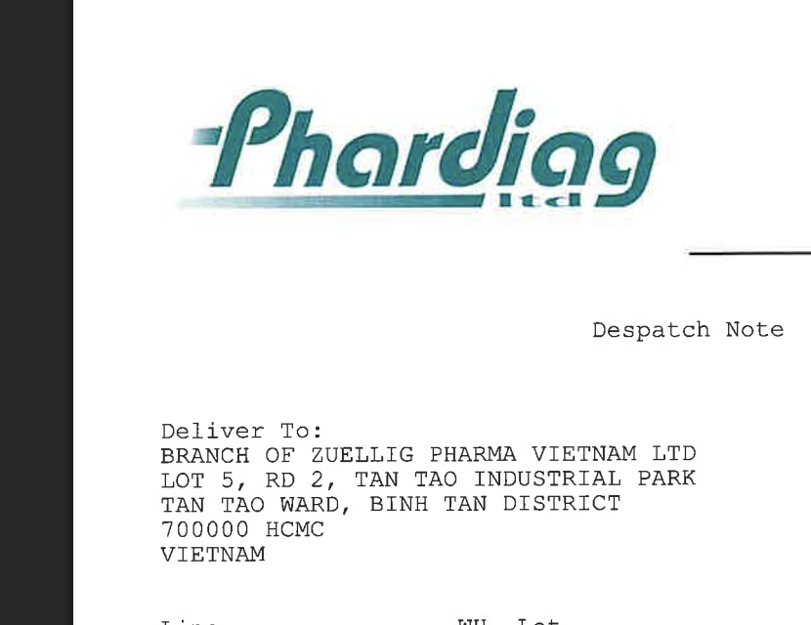
* OCR unable to identify between “O” and “0”  
  (Please view image below)  
  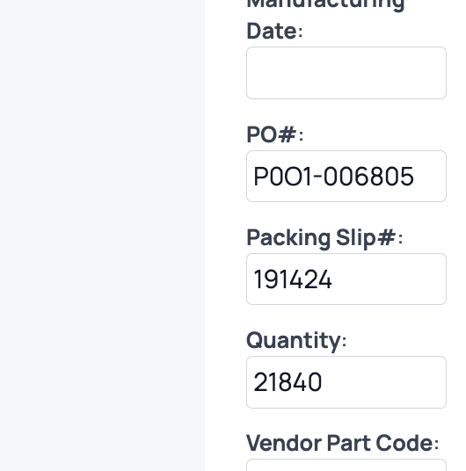
* Add icon “?” to assist user understanding of each individual function
* What is category 1 and 2?

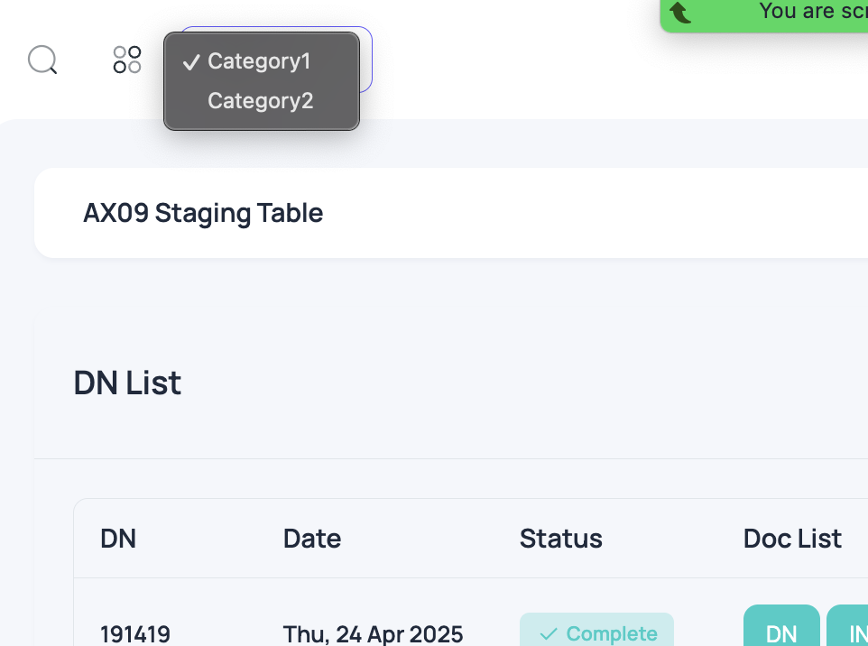

* Please add “PO list” via the menu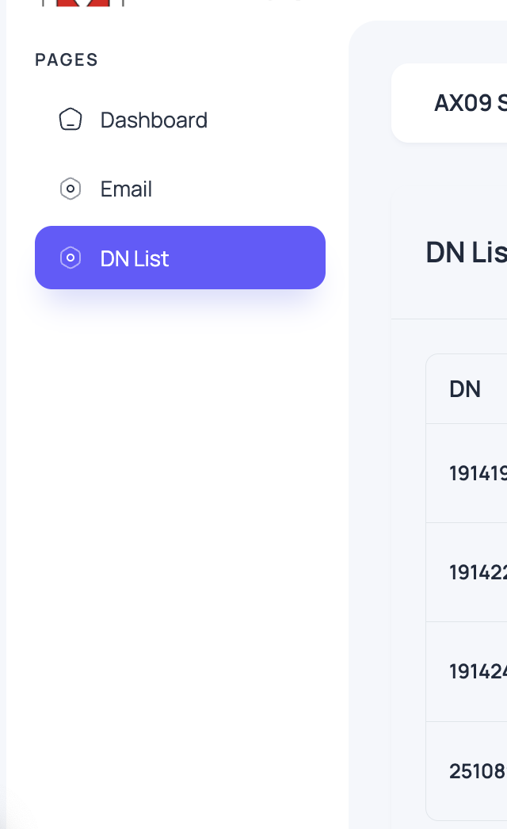

14) this dashboard icon does not direct to dashboard but the “My profile” button will direct user to dashboard

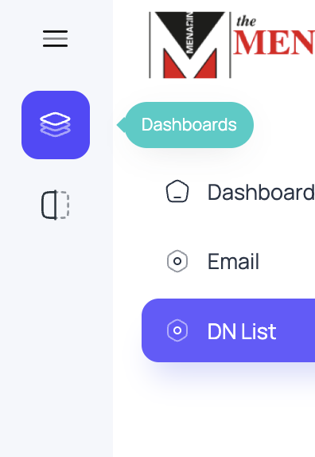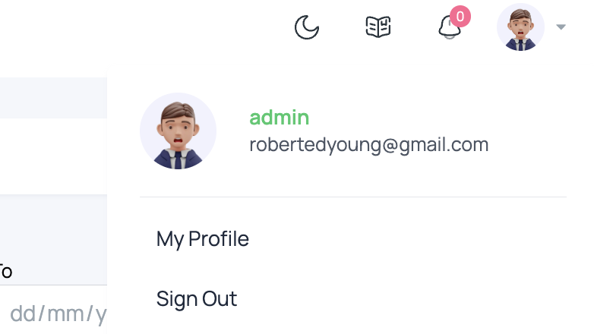

* Unable to click this, and what's the feature?

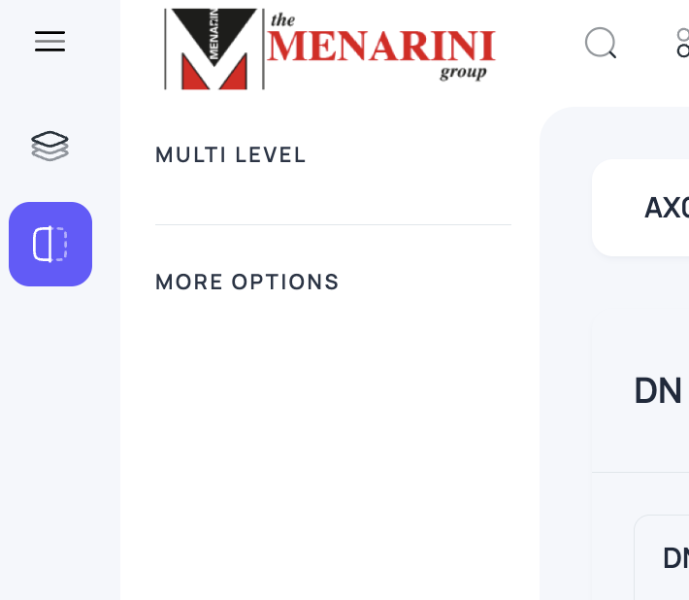

* Is this going to be removed?

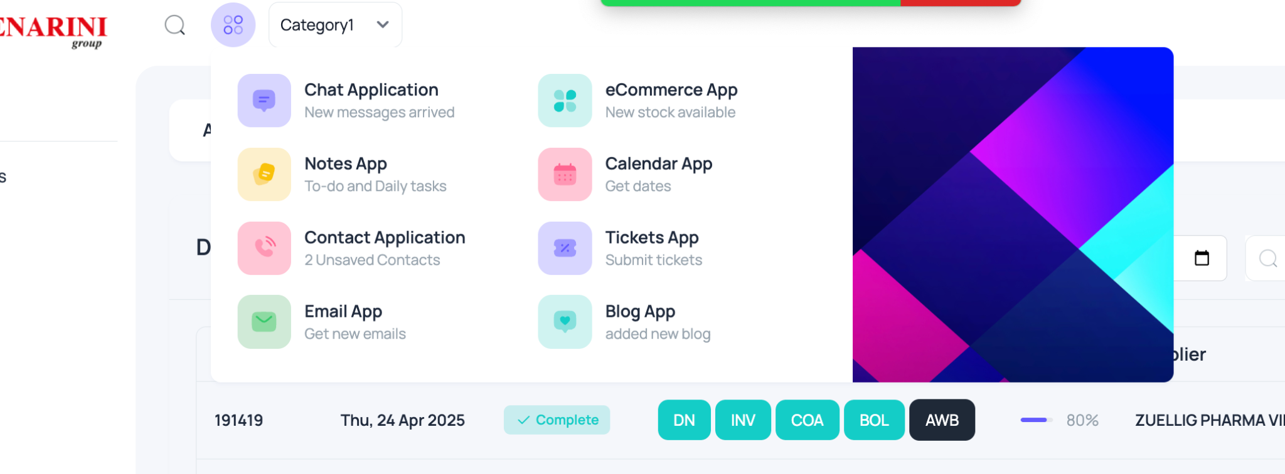

* So same goes to this, is this gonna be removed?

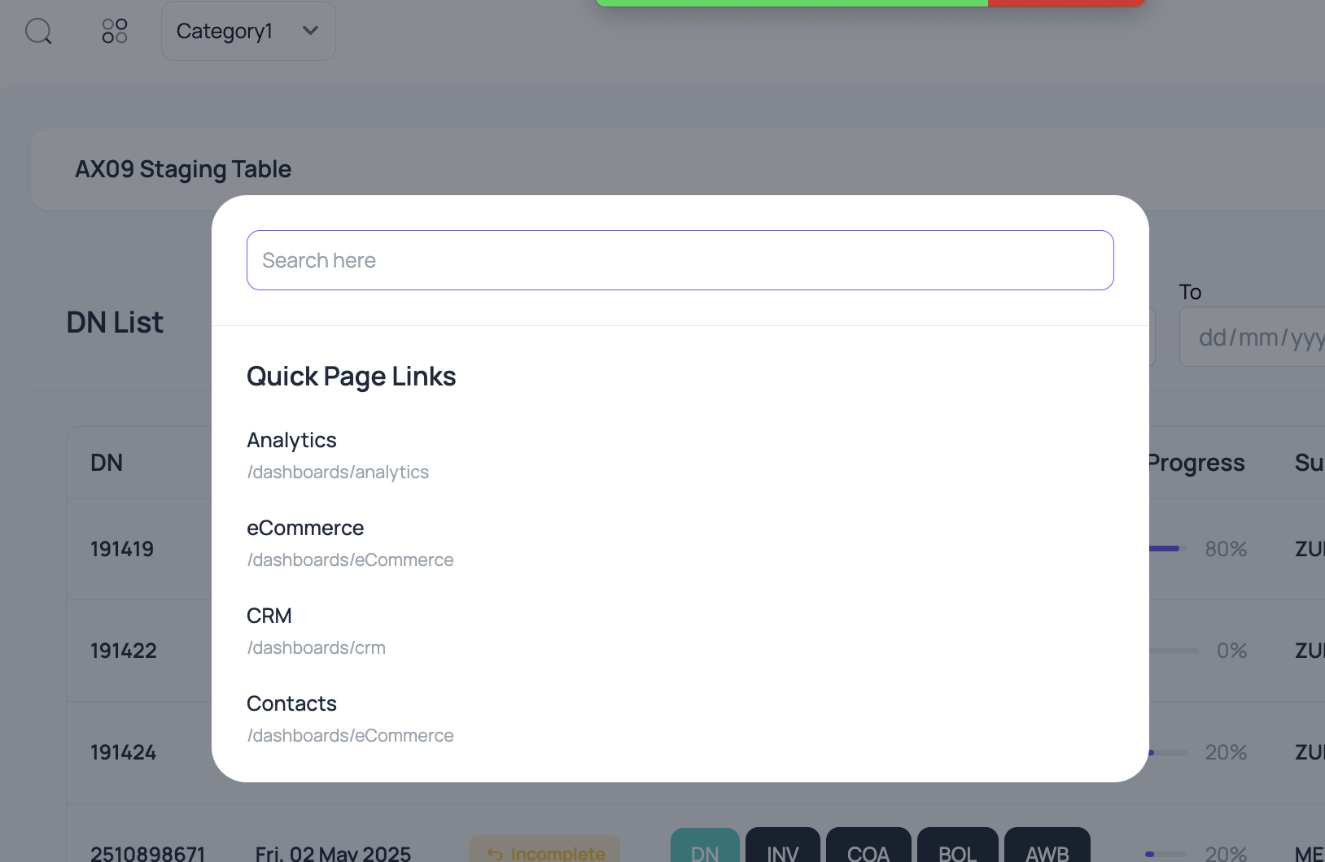

* What is this book icon for? And why we are being redirected to dashboard after clicking the “attachment error”

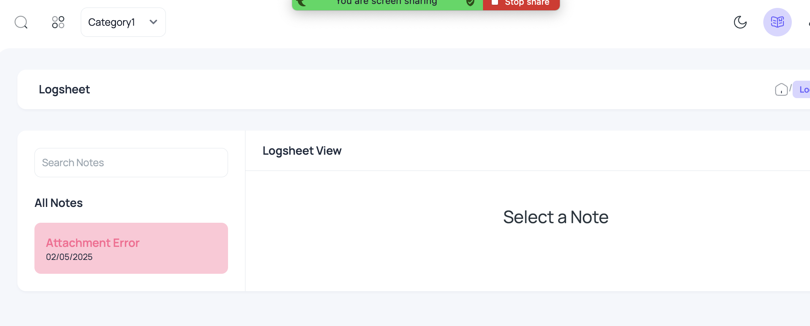

* No notification was received, even error shown on DN#191422

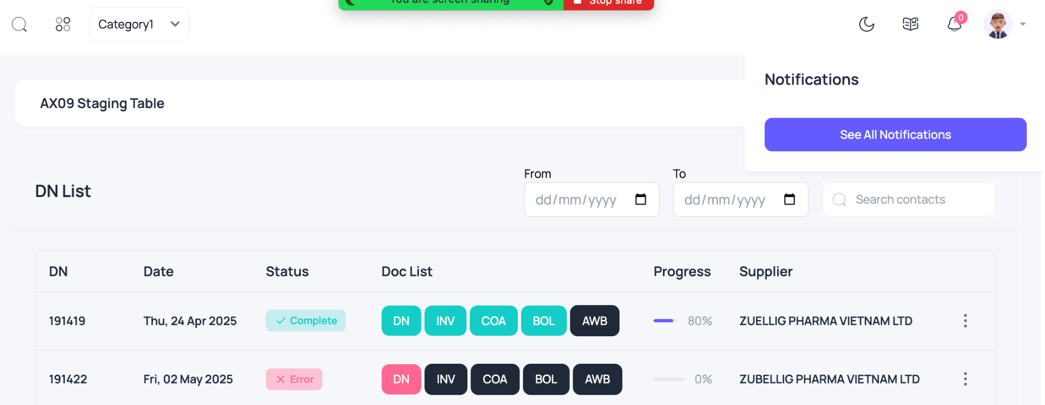

* How to use all this?

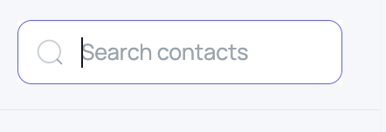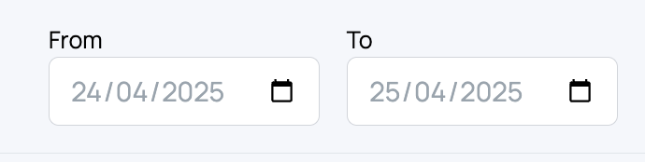

* Date should have function to arrange ascending and descending
* In additional, we tried to use [zec.h@arkinno-ai.com](mailto:zec.h@arkinno-ai.com) to send DN but is not working, but previous [zec.h@arkinno-ai.com](mailto:zec.h@arkinno-ai.com) did send a document to the system and it works.